“Fit for Partnership with Germany”
The Manager Training Programme of the
Federal Ministry for Economic Affairs and Climate Action (BMWK)

The Manager Training Programme of the Federal Ministry for Economic Affairs and Climate Action (MP) is an element of Germany’s foreign trade policy. Under the title of “Fit for Partnership with Germany”, the Programme prepares managers from selected partner countries* to do business with German small and medium-sized enterprises (SMEs) and brings the parties together. The MP was initiated in 1998. Since then, the concept of the Programme has been continuously developed and its contents adapted to current needs. This ensures the long-term success and the future viability of the MP. More than 17,000 executives have already completed the Programme. In the course of the travel restrictions due to the pandemic, the MP was implemented in a virtual form in 2020 and 2021. Since 2022, the MP has been offered in a further developed format combining the advantages of the virtual training and proven classroom-based modules. This prepares the participants optimally for cooperation with the German business community.

The social blended learning concept for maximum business success
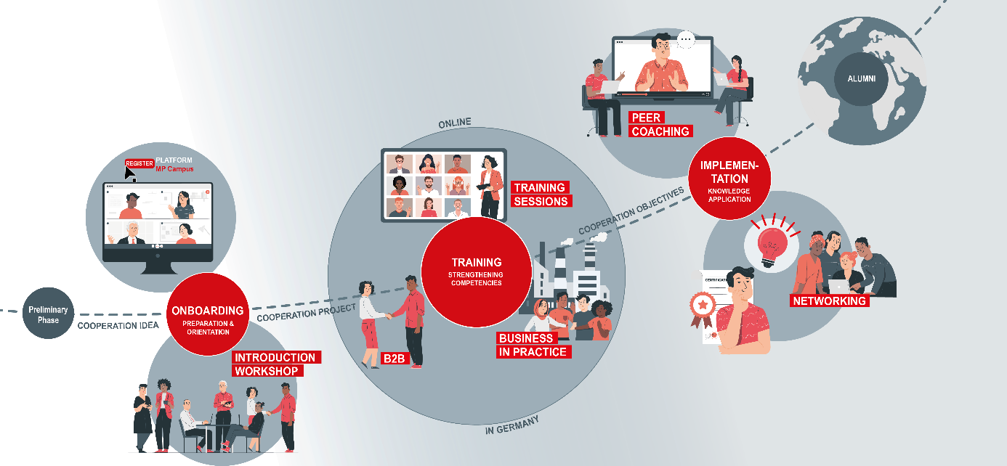

Units in the online and face-to-face format (blended learning) will alternate in the Programme In study groups and study tandems as well as through various forms of coaching, the exchange among the participants is strengthened and established as a modern form of skills development (social learning). This training format is supported through the digital learning and communication platform, “MP Campus”, which was developed precisely for that purpose. The modules of the online training are carried out on this platform, and it enables the communication among the participants as well as continuous learning guidance. The highlight of the interplay between the online programme and presence format is the two-week stay in Germany. During this stay, the participants come into personal contact with representatives of
the German business community. The training takes place in groups of approx. 20 executives. It comprises three phases followed by a closing networking event in the home country.

Phase 1: Onboarding
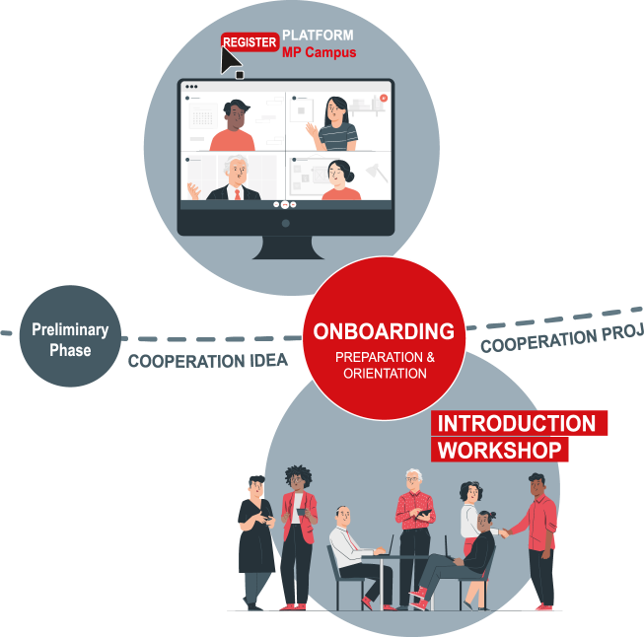
During the two-week onboarding phase, the technical and organisational prerequisites are created so that the training runs smoothly, the expectations of the participants are determined and access to the contents of the Programme ensured. This takes place during virtual onboarding on the “MP Campus” platform. Next comes a two-day introduction workshop in the home country, which is organised and carried out by the German training centre. At the centre of this phase is the exchange of opinions and experience among the participating managers about the challenges they face in their everyday work and their personal or business objectives. These are the subject of the binding individual business cooperation project of each participant; at this point, they are checked for feasibility and the content then honed. In addition, the participants are introduced to the topics relevant to initiating business cooperation with Germany. Getting to know each other within a group helps to form study groups and is the basis for trustful collaboration.

Phase 2: Training
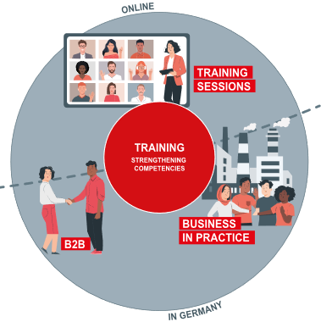
The training phase is designed as the interplay between the three proven core elements of the MP: interactive and practice-oriented training sessions, company visits and individual meetings with German companies (B2B). The phase begins with a six-week online segment. Here the main emphasis is on interactive training sessions, which serve to impart knowledge and apply this knowledge in practical exercises. In parallel, the participants prepare themselves for their individual meetings with German companies. The online programme is followed up with a two-week stay in Germany, which focuses on the executives’ direct experience with Germany as a business location. This is done, on the one hand, through company visits with the group, during which they gain first-hand practical expertise from German companies and get to know state-of-the-art technology and equipment on site. On the other hand, the participants have individual B2B meetings with their potential business partners. They put their newly acquired knowledge to use in negotiations. At the end of the training phase, the participants have the tools they need to achieve their personal and business objectives.

Phase 3: Transfer
During the six-month transfer phase, the participants work on the implementation of their cooperation objectives and initiate processes for change in their own companies.
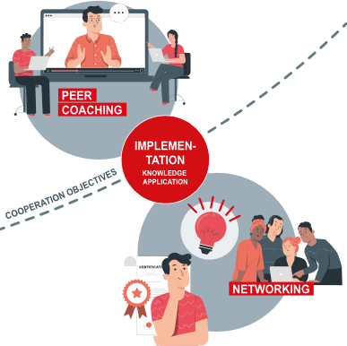
The German training centre consistently encourages the exchange of knowledge and experience among the participants via “MP Campus”. In monthly online meetings, the managers can reflect on progress made and discuss open questions with the support of the training centre. Current issues can also be dealt with in the group through peer-to-peer consulting in the form of co-coaching. Further training units round off this phase. The transfer phase and, with that, the training as a whole, ends with an evaluation of the results.

Networking event
A two-day networking event is held in the participants’ home country shortly after completion of the training. This event provides an opportunity for contact with other MP alumni (from previous years), the personal evaluation of the participation in the Programme and the presentation of the results achieved with business cooperation and changes made. The handover of the certificates of attendance is the ceremonial highlight of the function.
The event is organised jointly by GIZ, the local implementing partners and the German training centre. Representatives from the German embassies, German chambers of commerce abroad, partner organisations and local alumni networks attend this event to support the integration of the fresh alumni into existing networks. The alumni work in the MP stands for long lasting and sustainable contacts within a familiar environment.

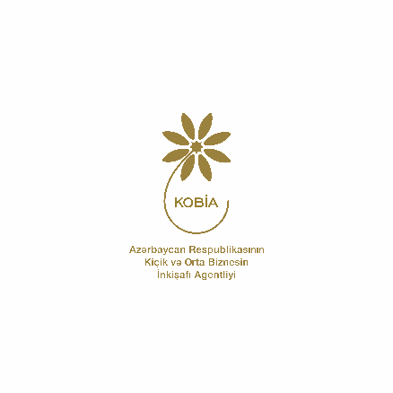
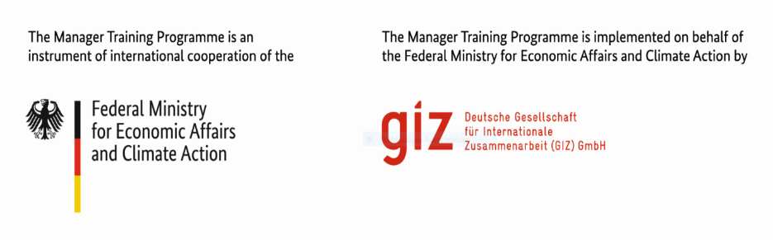

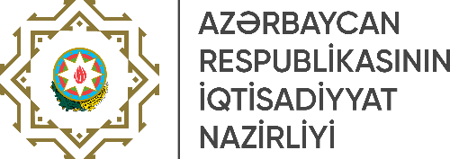

*For current partner countries please check our website www.managerprogramme.com

